

Parents Handbook and Policies
License #493009879

Lisa Morgan: (707) 861-2188
lisa@lakewoodbees.com
Thank you for considering our home-based childcare for your family! It is our mission to give children the opportunity to learn and grow to their fullest potential in a safe and nurturing environment. We maintain a very low child to adult ratio (averaging 1:4) in order to give all of our children individualized attention in a relaxed environment.
Philosophy: We believe in the principles of the RIE philosophy and extend it to all children in our care. The basis of Magda's Gerber's RIE philosophy is respect for, and trust in the child to be an initiator, an explorer, and a self-learner. Magda encouraged parents and caregivers to provide:
- An environment for the child that is physically safe, cognitively challenging and emotionally nurturing.
- Time for uninterrupted play.
- Freedom to explore and interact with other children.
- Involvement of the child in all care activities to allow the child to become an active participant rather than a passive recipient.
- Sensitive observation of the child in order to understand his or her needs.
- Consistency, clearly defined limits and expectations to develop discipline.
Education: Young children are natural learners! They learn by playing, communicating, and experiencing the world. We offer age-appropriate educational opportunities daily. What does this mean? Access to art, sensory activities, dramatic play, books, gross motor play, musical instruments, etc. We let the children choose their activities which encourages decision making skills, creativity, imagination, social skills, problem-solving skills, etc.
What I provide: I provide a safe, loving, nurturing, home-like environment, healthy, homemade and mostly organic foods, diapers, wipes, and lots of fun! Randy and I are both licensed childcare providers; We are up to date on our immunizations/TB tests, mandatory reporter training, infant/child/adult first-aid and CPR training, and health and safety training.
What parents provide: diaper ointment, formula/breast milk, bottles, spare clothes, sunblock
Hate and Nondiscrimination: I will not discriminate against any child or family based on race, national origin, religion, sex, or disability. Furthermore, discriminatory language and behavior on the premises are grounds for immediate termination.
Hours: We are open from 8am-5:30pm, Monday through Friday unless otherwise agreed ahead of time.
Drop off/Pick up: You can park in the driveway or anywhere along the curb that doesn't block our neighboring driveways. Only those listed on your permission sheet can pick up and they must show ID before the child is released.
Late pickup or early drop off will incur a $3/min charge unless an alternative arrangement is made in advance.
Tuition Rates:
The following rates are for a monthly spot in our program. Rates remain the same regardless of attendance and are due on the first of the month prior to care.
Payments can be made in cash, check, or electronically via Brightwheel.
Late payments will incur a $25/day charge.
Enrollment:
To enroll in our program, we require a $100 enrollment fee, a two-week deposit which is credited toward your child’s last two weeks in care, and all paperwork completed/returned. The spot will not be held for your child until these requirements are met.
Brightwheel App: We utilize the Brightwheel App to update you about your child’s day. You receive updates on their meals/snacks, activities, naps, etc. as well as photos/videos. You can also setup autopay within the app.
Vacations/Holidays: A calendar is handed out at the beginning of every year with our updated closure dates on it, as they can vary year by year. We close for major federal holidays such as Labor Day, Christmas, Thanksgiving, July 4th, etc. We also take 14 personal days. We pride ourselves in being reliable and do not close excessively.
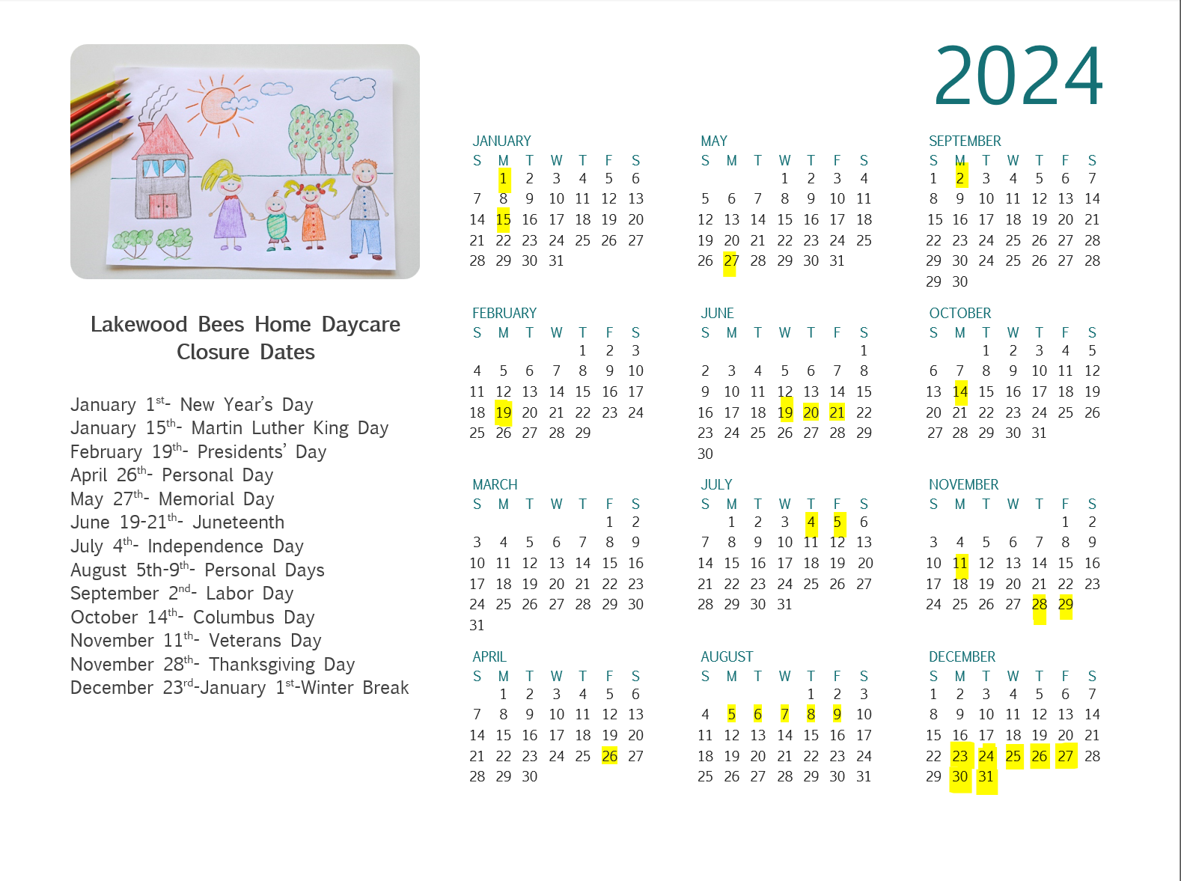
Emergency Closures: If for some reason outside of my control I am forced to temporarily close, full tuition would still be required.
Safety: Your child's safety is paramount. All lower cabinets (kitchen and bathroom) have safety locks. Upper cabinets that could pose a problem (i.e. medicine cabinet) are also locked. All electrical outlets have child proof safety covers. The doors have knob covers to prevent tiny escape artists from going anywhere they shouldn’t. I have smoke detectors, carbon monoxide detectors, and a fire extinguisher. Emergency numbers are posted by the phone. I also have two first aid kits at the ready. Earthquake and fire drills are practiced regularly. Our home is also regularly inspected and approved by a state childcare licensing analyst and the Sonoma County fire marshal.
Still, kids at play will get hurt. It’s an unfortunate eventuality no matter how much we try to avoid it. Little bumps/bruises will be taken care of with bandaids/hugs/ice and reported to the parent at pickup. More unfortunate accidents (goose egg, biting, etc.) will result in an incident report sent via Brightwheel.
Clothing: Playing can get messy! Please send your child in play clothes only. Comfortable clothes they can move/play in and isn't a big deal if it gets paint, dirt, etc. on it.
Make sure your child always has one complete change of clothing here, including underwear, hat and socks. Please provide a different change of clothes should the one here be used or if the season changes. Please label everything!
Close-toed shoes only! Please no flip flops.
If your child arrives in clothing that inhibits his/her ability to participate in the program they will either need to go home or you will have to bring the needed attire.
Mandated reporting: As a licensed childcare provider I am a mandated reporter. All providers must report suspected physical abuse, sexual abuse, or neglect of a child to the agency or police as required by the state of California. This is simply listed to make you aware. In the event you have concerns about my care, you can contact 1-844-LET-US-NO
Items from home: your child may bring a special blanket or stuffy for quiet time. Soft toys that are attached to pacifiers are against regulations so cannot be allowed. Please do not allow your child to bring toys, snacks (unless discussed beforehand), money, etc.
Meals and snacks:
I will provide well rounded, healthy and mostly organic foods. All food served during the day will include servings from each basic food group as specified by the United States Department of Agriculture.
If any food or bottles are brought from home, they must be clearly labeled with the child's name. It is important for me to know if your child has any known allergies or other eating restrictions.
Sick Policy: Symptom-free
What does symptom-free mean?
If your child has any of the following:
- sore throat
- cough
- runny nose
- congestion
- headache
- stomachache
- loose bowel movements
- fever (over 100 degrees Fahrenheit)
- unusual fussiness
Simple, right? Symptom-free. We exclude for any of these symptoms, regardless of if there is a suspected cause(allergies, teething).
When can your child come back to care?
When they’re no longer contagious! A common cold is typically contagious for as long as a person is symptomatic. This can mean anything from 3-14 days depending on the illness. If your child had a fever, they can come back 48hrs after being fever free without the use of medicine. We understand that little ones can have lingering symptoms well after they’ve gotten better so please be in communication with us about how your little one is feeling and we will determine this on a case-to-case basis.
Sick people in the household:
If anyone in the household, such as parents or a sibling, has symptoms of illness then your child will also be excluded from care. Why? Colds/flus/covid are all contagious before symptoms even start. If you/a family member are sick, it is very likely that your child will bring those germs to all their friends.
We will conduct daily health checks at the door
We will do a temperature check and ask all the typical questions to ensure our friends are healthy before entering. If your child is unwell, we will have to turn you away at the door. This is very confusing and sad for them as they are ready to go play with their friends so, please do your own check at home. Furthermore, if we discover that they are in fact ill within 30mins of drop off, you will be charged an additional $45 for the day since it is very unlikely that their symptoms just appeared within that time frame. It is your responsibility to be aware of your child’s health and keep them home if they are symptomatic.
What if a child become symptomatic while in care?
This is bound to happen occasionally! Your child will be placed in a quiet room to await your arrival. You will be required to pick up your sick child within one hour after being contacted or there is a $5/min late fee. It is very important that you have a plan in place for backup care.
Please remember, my goal is not to keep your children out of care. It’s the opposite! I want to keep everyone healthy and present with us!
Head Lice Policy: It is the responsibility of all parents to check their child's hair weekly for head lice and to provide adequate treatment if head lice is found. If your child has head lice, you need to inform me right away. This way I can inform all other parents that head lice has been found in the daycare. The sooner all parents are aware of the lice the sooner they can check their children and we can stop the outbreak before it gets too big.
An infected child can return to daycare 48 hours after the 2nd treatment has been done and that you have confirmed that all lice are dead and the nits (eggs) have been removed.
The treatments can be done within 7 to 10 days from each other, depending on the treatment used.
It takes 10 days for an egg to hatch, if you miss just one then you will have a whole new outbreak. This is why you need to keep your child home this long.
During a head lice outbreak my Daycare will remain open for all non-infected children. It is up to you whether to bring your non-infected child or not. However, if I or a member of my family have lice, I will have to close.
Payment will still be due in full.
All steps will be taken to remove any head lice from the Daycare/my home as quickly and safely as possible.
Immunizations: As a state licensed daycare all children are required to have up to date immunizations for their age. We encourage but do not require covid vaccination.
Medications: Prior to administering prescription medication I must have written permission and instructions for each medication. Medicine with the child's name and current prescription information on the label constitutes instructions.
Non-prescription medications will be administered with parental permission according to the manufacturer's instructions unless written instructions from a licensed physician state otherwise. Parents must sign a permission slip for each medication.
Sleeping: Each child will be provided with a safe, comfortable sleeping space with separate bedding. Infants will sleep in a mini crib with a waterproof mattress and fresh sheet. They will use a clean sleep sack as needed. I will sleep infants on their backs according to the recommended guidelines from the AAP. If your baby is old enough to roll onto their stomach has this preference you may give written consent for this alternative position. Infants will be checked at least every 15mins for normal breathing.
Toddlers sleep on a cushioned waterproof mat and are provided with a nap mat style pillow/blanket.
All bedding is provided by us. It is used by one child and laundered at the end of the week (or sooner if needed)
Emergencies/Backup: It is required that you have a backup babysitter (friend, family, etc) available should your child become ill or if we need to close for illness.
Should your child require emergency medical attention I need written permission to follow any steps necessary for his/her wellbeing. I will notify you at the earliest possible time should such a situation occur. You will be responsible for all medical expenses incurred.
Authorized Persons: Occasionally your child may need to be picked up from care by someone other than a parent/guardian. Unless the names are listed on your emergency forms, your child will not be released. In case of an emergency, please provide a reliable list of people to reach.
Parents in daycare: you have the right to stop in anytime during your child's regular daycare hours. If you are picking up outside of your regular time, it is helpful to message ahead since we may be messy, out at the park, etc.
Smoking: this is a smoke free home! You are not allowed to smoke anywhere on the property regardless of whether it is daycare hours.
Scents: scents can be overwhelming to some of our more sensitive children. We ask that you limit your use of scented products on your child.
Termination: If you decide to terminate care, I require two weeks’ notice. The last two weeks of payment will be due, regardless of attendance.
Daycare forms: All forms must be completed prior to the first day of care. All weekly fees must be paid prior to the start of care in any given week. If forms are not completed or fees are not paid, no care will be provided.

The undersigned have read and agree to abide by these policies.

_______________________________ _______________
(parent signature) (Date)

_______________________________ _______________
(parent signature) (Date)

